**Digital Design and Computer Organization**

Semester 2, 2023

*Lab 9 & 10*

Nano Processor

Team Number: 56

Team Members

* J.P.S.A. Chandrawansha – 210077D
* P.H.T. Dinujaya – 210134C

Tasks:

* Developed the basic logic units such as D flip-flop, tri-state buffer, 4-bit register, slow clock which are needed to build other logical systems of the processor.
* Develop 4-bit arithmetic unit to adding and subtracting signed integers.
* Design decoders to integrate into some other logical parts of the processor like register bank for register selecting and multiplexer for data selection.
* Designed various types of multiplexers by using pre-built decoders and tri-state buffers.
* Created the program-ROM to store our assembly program in binary format.
* Designed and developed the instruction decoder of the processor.
* Assembled all the logical systems we built, to finally construct the whole Nano-processor.
* Test functionality of the various logic parts and the processor throughout series of simulations and confirm that are work fine.

Assembly Code

Assembly instructions

MOVI R7, 10 *; R7 <- 10*

MOVI R1, 1  *; R1 <- 1*

NEG R1      *; R1 <- -R1*

ADD R7, R1  *; R7 <- R7 + R1*

JZR R7, 7   *; If R7 = 0 jump to line 7*

JZR R0, 3   *; If R1 = 0 jump to line 3*

Machine instructions

101110001010

100010000001

010010000000

001110010000

111110000111

110000000011

VHDL Codes

*Visit [nano-processor](https://github.com/shavinanjitha2002/NanoProcessor.git) git-hub repository for Project Repository.

**HA**

library IEEE;

use IEEE.STD_LOGIC_1164.ALL;

entity HA is

    Port ( A : in STD_LOGIC;

           B : in STD_LOGIC;

           S : out STD_LOGIC;

           C : out STD_LOGIC);

end HA;

architecture Behavioral of HA is

begin

    S <= A XOR B;

    C <= A AND B;

end Behavioral;

**FA**

library IEEE;

use IEEE.STD_LOGIC_1164.ALL;

entity FA is

    Port ( A : in STD_LOGIC;

           B : in STD_LOGIC;

           C_in : in STD_LOGIC;

           S : out STD_LOGIC;

           C_out : out STD_LOGIC);

end FA;

architecture Behavioral of FA is

    Component HA

        Port (

            A : in STD_LOGIC;

            B : in STD_LOGIC;

            S : out STD_LOGIC;

            C : out STD_LOGIC

        );

    End Component;

    SIGNAL HA0_S, HA0_C, HA1_C : STD_LOGIC;

begin

    HA_0 : HA

        PORT MAP (

            A => A,

            B => B,

            S => HA0_S,

            C => HA0_C

        );

    HA_1 : HA

        PORT MAP (

            A => HA0_S,

            B => C_in,

            S => S,

            C => HA1_C

        );

    C_out <= HA0_C OR HA1_C;

end Behavioral;

**3 Bit Adder**

library IEEE;

use IEEE.STD_LOGIC_1164.ALL;

entity Adder_3 is

    Port ( A_in : in STD_LOGIC_VECTOR (2 downto 0);

           S_out : out STD_LOGIC_VECTOR (2 downto 0));

end Adder_3;

architecture Behavioral of Adder_3 is

Component FA

    PORT(

        A : in STD_LOGIC;

        B : in STD_LOGIC;

        C_in : in STD_LOGIC;

        S : out STD_LOGIC;

        C_out : out STD_LOGIC

    );

End Component;

    SIGNAL FA_C_out : STD_LOGIC_VECTOR(2 downto 0);

begin

    FA_0 : FA

        PORT MAP(

            A => A_in(0),

            B => '1',

            S =>  S_out(0),

            C_in => '0',

            C_out => FA_C_out(0));

    FA_1 : FA

        port map(

            A => A_in(1),

            B => '0',

            S =>  S_out(1),

            C_in => FA_C_out(0),

            C_out => FA_C_out(1));

    FA_2 : FA

        PORT MAP(

            A => A_in(2),

            B => '0',

            S =>  S_out(2),

            C_in => FA_C_out(1),

            C_out => FA_C_out(2));

end Behavioral;

**Buffer**

library IEEE;

use IEEE.STD_LOGIC_1164.ALL;

entity Buff_3 is

    Port ( D : in STD_LOGIC_VECTOR (2 downto 0);

           Ctrl : in STD_LOGIC;

           Y : out STD_LOGIC_VECTOR (2 downto 0));

end Buff_3;

architecture Behavioral of Buff_3 is

begin

    Y <= D WHEN Ctrl = '1' ELSE "ZZZ";

end Behavioral;

**Mux_2_Way_3**

library IEEE;

use IEEE.STD_LOGIC_1164.ALL;

entity Mux_2_way_3 is

    Port ( I : in STD_LOGIC;

           A0, A1 : STD_LOGIC_VECTOR(2 downto 0);

           Y : out STD_LOGIC_VECTOR (2 downto 0));

end Mux_2_way_3;

architecture Behavioral of Mux_2_way_3 is

    Component Buff_3

        PORT (

            D : in STD_LOGIC_VECTOR(2 downto 0);

            Ctrl : in STD_LOGIC;

            Y : out STD_LOGIC_VECTOR(2 downto 0)

        );

    End Component;

    SIGNAL NOT_I : STD_LOGIC;

begin

    NOT_I <= NOT(I);

    Buff_3_0 : Buff_3 PORT MAP(D => A0, Ctrl => NOT_I, Y => Y);

    Buff_3_1 : Buff_3 PORT MAP(D => A1, Ctrl => I, Y => Y);

end Behavioral;

**4 Bit Buffer**

library IEEE;

use IEEE.STD_LOGIC_1164.ALL;

entity Buff_4 is

    Port ( D : in STD_LOGIC_VECTOR (3 downto 0);

           Ctrl : in STD_LOGIC;

           Y : out STD_LOGIC_VECTOR (3 downto 0));

end Buff_4;

architecture Behavioral of Buff_4 is

begin

    Y <= D WHEN Ctrl = '1' ELSE "ZZZZ";

end Behavioral;

**Mux_2_Way_4**

library IEEE;

use IEEE.STD_LOGIC_1164.ALL;

entity Mux_2_way_4 is

    Port ( I : in STD_LOGIC;

           A0, A1 : in STD_LOGIC_VECTOR (3 downto 0);

           Y : out STD_LOGIC_VECTOR (3 downto 0));

end Mux_2_way_4;

architecture Behavioral of Mux_2_way_4 is

    Component Buff_4

        PORT (

            D : in STD_LOGIC_VECTOR(3 downto 0);

            Ctrl : in STD_LOGIC;

            Y : out STD_LOGIC_VECTOR(3 downto 0)

        );

    End Component;

    SIGNAL NOT_I : STD_LOGIC;

begin

    NOT_I <= NOT(I);

    Buff_4_0 : Buff_4 PORT MAP(D => A0, Ctrl => NOT_I, Y => Y);

    Buff_4_1 : Buff_4 PORT MAP(D => A1, Ctrl => I, Y => Y);

end Behavioral;

**Decoder_2_to_4**

library IEEE;

use IEEE.STD_LOGIC_1164.ALL;

entity Decoder_2_to_4 is

    Port ( I : in STD_LOGIC_VECTOR (1 downto 0);

           En : in STD_LOGIC;

           Y : out STD_LOGIC_VECTOR (3 downto 0));

end Decoder_2_to_4;

architecture Behavioral of Decoder_2_to_4 is

begin

    Y(0) <= En AND NOT(I(0)) AND NOT(I(1));

    Y(1) <= En AND I(0) AND NOT(I(1));

    Y(2) <= En AND NOT(I(0)) AND I(1);

    Y(3) <= En AND I(0) AND I(1);

end Behavioral;

**Decoder_3_to_8**

library IEEE;

use IEEE.STD_LOGIC_1164.ALL;

entity Decoder_3_to_8 is

    Port ( I : in STD_LOGIC_VECTOR (2 downto 0);

           En : in STD_LOGIC;

           Y : out STD_LOGIC_VECTOR (7 downto 0));

end Decoder_3_to_8;

architecture Behavioral of Decoder_3_to_8 is

    Component Decoder_2_to_4

        PORT (

            I : in STD_LOGIC_VECTOR(1 downto 0);

            En : in STD_LOGIC;

            Y : out STD_LOGIC_VECTOR(3 downto 0)

        );

    End Component;

    SIGNAL En_0, En_1 : STD_LOGIC;

begin

    Decoder_2_to_4_0 : Decoder_2_to_4

        PORT MAP (

            I => I(1 downto 0),

            En => En_0,

            Y => Y(3 downto 0)

        );

    Decoder_2_to_4_1 : Decoder_2_to_4

        PORT MAP (

            I => I(1 downto 0),

            En => En_1,

            Y => Y(7 downto 4)

        );

    En_0 <= En AND NOT(I(2));

    En_1 <= En AND I(2);

end Behavioral;

**Register**

library IEEE;

use IEEE.STD_LOGIC_1164.ALL;

entity Reg is

    Port ( Clk : in STD_LOGIC;

           En : in STD_LOGIC;

           Rst : in STD_LOGIC;

           D : in STD_LOGIC_VECTOR (3 downto 0);

           Q : out STD_LOGIC_VECTOR (3 downto 0));

end Reg;

architecture Behavioral of Reg is

begin

    process (Clk, Rst) begin

        if Rst'event AND Rst = '1' then Q <= "0000"; -- reset the register asynchronously

        else if (rising_edge(Clk)) then -- respont at the rising edge of the clock pulse

            if En = '1' then -- store the 4-bit fi En is asserted

                Q <= D;

            end if;

        end if;

        end if;

    end process;

end Behavioral;

**Register Bank**

library IEEE;

use IEEE.STD_LOGIC_1164.ALL;

entity Reg_Bank is

    Port ( I : in STD_LOGIC_VECTOR (3 downto 0);

           Clk : in STD_LOGIC;

           Rst : in STD_LOGIC;

           Reg_En : in STD_LOGIC_VECTOR (2 downto 0);

           R0 : out STD_LOGIC_VECTOR (3 downto 0);

           R1 : out STD_LOGIC_VECTOR (3 downto 0);

           R2 : out STD_LOGIC_VECTOR (3 downto 0);

           R3 : out STD_LOGIC_VECTOR (3 downto 0);

           R4 : out STD_LOGIC_VECTOR (3 downto 0);

           R5 : out STD_LOGIC_VECTOR (3 downto 0);

           R6 : out STD_LOGIC_VECTOR (3 downto 0);

           R7 : out STD_LOGIC_VECTOR (3 downto 0));

end Reg_Bank;

architecture Behavioral of Reg_Bank is

    Component Reg

        PORT (

            D : in STD_LOGIC_VECTOR(3 downto 0);

            Clk : in STD_LOGIC;

            Rst : in STD_LOGIC;

            En : in STD_LOGIC;

            Q : out STD_LOGIC_VECTOR(3 downto 0)

        );

    End Component;

    Component Decoder_3_to_8

        PORT (

            I : in STD_LOGIC_VECTOR (2 downto 0);

            En : in STD_LOGIC;

            Y : out STD_LOGIC_VECTOR (7 downto 0)

        );

    End Component;

    SIGNAL Decoder_Y : STD_LOGIC_VECTOR(7 downto 0);

begin

    Decoder_3_to_8_0 : Decoder_3_to_8

        PORT MAP(

            I => Reg_En,

            En => '1',

            Y => Decoder_Y

        );

    Reg_0 : Reg

        PORT MAP(

            D => I,

            Clk => Clk,

            Rst => Rst,

            En => Decoder_Y(0),

            Q => R0

        );

    Reg_1 : Reg

        PORT MAP(

            D => I,

            Clk => Clk,

            Rst => Rst,

            En => Decoder_Y(1),

            Q => R1

        );

    Reg_2 : Reg

        PORT MAP(

            D => I,

            Clk => Clk,

            Rst => Rst,

            En => Decoder_Y(2),

            Q => R2

        );

    Reg_3 : Reg

        PORT MAP(

            D => I,

            Clk => Clk,

            Rst => Rst,

            En => Decoder_Y(3),

            Q => R3

        );

    Reg_4 : Reg

        PORT MAP (

            D => I,

            Clk => Clk,

            Rst => Rst,

            En => Decoder_Y(4),

            Q => R4

        );

    Reg_5 : Reg

        PORT MAP(

            D => I,

            Clk => Clk,

            Rst => Rst,

            En => Decoder_Y(5),

            Q => R5

        );

    Reg_6 : Reg

        PORT MAP(

            D => I,

            Clk => Clk,

            Rst => Rst,

            En => Decoder_Y(6),

            Q => R6

        );

    Reg_7 : Reg

        PORT MAP(

            D => I,

            Clk => Clk,

            Rst => Rst,

            En => Decoder_Y(7),

            Q => R7

        );

end Behavioral;

**4 Bit Adder and Subtractor**

library IEEE;

use IEEE.STD_LOGIC_1164.ALL;

entity Add_Subtract is

    Port ( A_in : in STD_LOGIC_VECTOR (3 downto 0);

           B_in : in STD_LOGIC_VECTOR (3 downto 0);

           S_out : out STD_LOGIC_VECTOR (3 downto 0);

           M : in STD_LOGIC;

           C_out : out STD_LOGIC;

           V : out STD_LOGIC);

end Add_Subtract;

architecture Behavioral of Add_Subtract is

Component FA

    PORT(

        A : in STD_LOGIC;

        B : in STD_LOGIC;

        C_in : in STD_LOGIC;

        S : out STD_LOGIC;

        C_out : out STD_LOGIC);

End Component;

    SIGNAL FA_C_out, B_in_temp : STD_LOGIC_VECTOR(3 downto 0);

begin

    B_in_temp(0) <= B_in(0) XOR M;

    B_in_temp(1) <= B_in(1) XOR M;

    B_in_temp(2) <= B_in(2) XOR M;

    B_in_temp(3) <= B_in(3) XOR M;

    FA_0: FA

        PORT MAP(

            A => A_in(0),

            B => B_in_temp(0),

            C_in => M,

            S => S_out(0),

            C_out => FA_C_out(0));

    FA_1: FA

        PORT MAP(

            A => A_in(1),

            B => B_in_temp(1),

            C_in => FA_C_out(0),

            S => S_out(1),

            C_out => FA_C_out(1));

    FA_2: FA

        PORT MAP(

            A => A_in(2),

            B => B_in_temp(2),

            C_in => FA_C_out(1),

            S => S_out(2),

            C_out => FA_C_out(2));

    FA_3: FA

        PORT MAP(

            A => A_in(3),

            B => B_in_temp(3),

            C_in => FA_C_out(2),

            S => S_out(3),

            C_out => FA_C_out(3));

    C_out <= FA_C_out(3);

    V <= FA_C_out(3) XOR FA_C_out(2);

end Behavioral;

**Mux_8_Way_4**

library IEEE;

use IEEE.STD_LOGIC_1164.ALL;

entity Mux_8_way_4 is

    Port ( Reg_Sel : in STD_LOGIC_VECTOR (2 downto 0);

           A0, A1, A2, A3, A4, A5, A6, A7 : in STD_LOGIC_VECTOR(3 downto 0);

           Y : out STD_LOGIC_VECTOR (3 downto 0));

end Mux_8_way_4;

architecture Behavioral of Mux_8_way_4 is

    Component Decoder_3_to_8

        PORT (

            I : in STD_LOGIC_VECTOR(2 downto 0);

            En : in STD_LOGIC;

            Y : out STD_LOGIC_VECTOR(7 downto 0)

        );

    End Component;

    Component Buff_4

        PORT (

            D : in STD_LOGIC_VECTOR(3 downto 0);

            Ctrl : in STD_LOGIC;

            Y : out STD_LOGIC_VECTOR(3 downto 0)

        );

    End Component;

    SIGNAL Decoder_Y : STD_LOGIC_VECTOR(7 downto 0);

begin

    Decoder_3_to_8_0 : Decoder_3_to_8

        PORT MAP(

            I => Reg_Sel,

            En => '1',

            Y => Decoder_Y

        );

    -- use the yti state buffers to pass selected 4-bits

    Buff_4_0 : Buff_4 PORT MAP(D => A0, Ctrl => Decoder_Y(0), Y => Y);

    Buff_4_1 : Buff_4 PORT MAP(D => A1, Ctrl => Decoder_Y(1), Y => Y);

    Buff_4_2 : Buff_4 PORT MAP(D => A2, Ctrl => Decoder_Y(2), Y => Y);

    Buff_4_3 : Buff_4 PORT MAP(D => A3, Ctrl => Decoder_Y(3), Y => Y);

    Buff_4_4 : Buff_4 PORT MAP(D => A4, Ctrl => Decoder_Y(4), Y => Y);

    Buff_4_5 : Buff_4 PORT MAP(D => A5, Ctrl => Decoder_Y(5), Y => Y);

    Buff_4_6 : Buff_4 PORT MAP(D => A6, Ctrl => Decoder_Y(6), Y => Y);

    Buff_4_7 : Buff_4 PORT MAP(D => A7, Ctrl => Decoder_Y(7), Y => Y);

end Behavioral;

**D Flip FLop**

library IEEE;

use IEEE.STD_LOGIC_1164.ALL;

entity D_FF is

    Port ( Clk : in STD_LOGIC;

           D : in STD_LOGIC;

           Rst : in STD_LOGIC;

           En : in STD_LOGIC;

           Q : out STD_LOGIC);

end D_FF;

architecture Behavioral of D_FF is

begin

    process (Clk, Rst) begin -- procss begin when clock changes

        if Rst'event AND Rst = '1' then Q <= '0'; -- reset the D flip-flop asynchronously

        else if (rising_edge(Clk)) then  -- respond at clock rising edge

            if En = '1' then -- store D if En is asserted

                Q <= D;

             end if;

         end if;

         end if;

    end process;

end Behavioral;

**Slow Clock**

IEEE;

use IEEE.STD_LOGIC_1164.ALL;

entity Slow_Clk is

    Port ( Clk_in : in STD_LOGIC;

           Clk_out : out STD_LOGIC);

end Slow_Clk;

architecture Behavioral of Slow_Clk is

    SIGNAL Count : integer := 1;

    SIGNAL Clk_status : STD_LOGIC := '0';

begin

    -- in this we slow down the clock speed for get visible output

    process (Clk_in) begin

        IF (rising_edge(Clk_in)) THEN

            Count <= count + 1;

            IF (Count = 2) THEN -- for this we are considering only 2 otherwise count = 5000000

                Clk_status <= NOT Clk_status;

                Clk_out <= Clk_status;

                Count <= 1;

            END IF;

        END IF;

    end process;

end Behavioral;

**3 Bit Counter**

library IEEE;

use IEEE.STD_LOGIC_1164.ALL;

entity Count_3 is

    Port ( Clk : in STD_LOGIC;

           rst : in STD_LOGIC;

           Add_in : in STD_LOGIC_VECTOR (2 downto 0);

           Add_out : out STD_LOGIC_VECTOR (2 downto 0));

end Count_3;

architecture Behavioral of Count_3 is

Component Slow_Clk

   PORT(

        Clk_in : in STD_LOGIC;

        Clk_out : out STD_LOGIC);

End Component;

Component D_FF

    PORT(

        Clk : in STD_LOGIC;

        D : in STD_LOGIC;

        Rst : in STD_LOGIC;

        En : in STD_LOGIC;

        Q : out STD_LOGIC);

End Component;

    SIGNAL Clk_Slow: STD_LOGIC;

begin

    -- this is for slow down the clock speed

    Slow_Clk_0 : Slow_Clk

        PORT MAP(

            Clk_in => Clk,

            Clk_out => Clk_Slow);

    -- left bit store

    D_FF_0 : D_FF

        PORT MAP(

            D => Add_in(0),

            Rst => rst,

            En => '1',

            Clk => Clk, -- Clk_Slow

            Q => Add_out(0));

    -- middle bit store

    D_FF_1 : D_FF

        PORT MAP(

            D => Add_in(1),

            Rst => rst,

            En => '1',

            Clk => Clk, -- Clk_Slow

            Q => Add_out(1));

    -- right bit store

    D_FF_2 : D_FF

        PORT MAP(

            D => Add_in(2),

            Rst => rst,

            En => '1',

            Clk => Clk, -- Clk_Slow

            Q => Add_out(2));

end Behavioral;

**ROM**

library IEEE;

use IEEE.STD_LOGIC_1164.ALL;

use IEEE.NUMERIC_STD.ALL;

entity ROM_8 is

    Port ( address : in STD_LOGIC_VECTOR (2 downto 0);

           ins : out STD_LOGIC_VECTOR (11 downto 0));

end ROM_8;

architecture Behavioral of ROM_8 is

    type rom_type is array (0 to 7) of std_logic_vector(11 downto 0);

    signal mem_8 : rom_type := ( "101110001010",

                                 "100010000001",

                                 "001110010000",

                                 "000000000000",

                                 "000000000000",

                                 "000000000000",

                                 "000000000000",

                                 "000000000000"

    );

begin

    ins <= mem_8(to_integer(unsigned(address)));

end Behavioral;

**Look up table for seven segment display**

library IEEE;

use IEEE.STD_LOGIC_1164.ALL;

use ieee.numeric_std.all;

entity LUT_7_Display is

    Port ( address : in STD_LOGIC_VECTOR (3 downto 0);

           data : out STD_LOGIC_VECTOR (6 downto 0));

end LUT_7_Display;

architecture Behavioral of LUT_7_Display is

type rom_type is array(0 to 15) of STD_LOGIC_VECTOR(6 downto 0);

    SIGNAL sevenSegment_ROM : rom_type := (

                            "1000000", -- 0

                            "1111001", -- 1

                            "0100100", -- 2

                            "0110000", -- 3

                            "0011001", -- 4

                            "0010010", -- 5

                            "0000010", -- 6

                            "1111000", -- 7

                            "0000000", -- 8

                            "0010000", -- 9

                            "0001000", -- a

                            "0000011", -- b

                            "1000110", -- c

                            "0100001", -- d

                            "0000110", -- e

                            "0001110" -- f

                            );

begin

    data <= sevenSegment_ROM(to_integer(unsigned(address)));

end Behavioral;

Simulations VHDL Codes

**FA Simulation**

library IEEE;

use IEEE.STD_LOGIC_1164.ALL;

entity FA_Sim is

--  Port ( );

end FA_Sim;

architecture Behavioral of FA_Sim is

    Component FA

        PORT (

            A : in STD_LOGIC;

            B : in STD_LOGIC;

            C_in : in STD_LOGIC;

            S : out STD_LOGIC;

            C_out : out STD_LOGIC

        );

    End Component;

    SIGNAL A, B, C_in : STD_LOGIC; -- input signals

    SIGNAL S, C_out : STD_LOGIC; -- output signals

begin

    UUT : FA PORT MAP (

        A => A,

        B => B,

        C_in => C_in,

        S => S,

        C_out => C_out

    );

    process

    begin

        -- set the A and B values

        A <= '0';

        B <= '0';

        C_in <= '0';

        wait for 10ns;

        A <= '1';

        wait for 10ns;

        B <= '1';

        wait for 10ns;

        A <= '0';

        WAIT FOR 10ns;

        C_in <= '1';

        wait for 10ns;

        B <= '0';

        wait for 10ns;

        A <= '1';

        wait for 10ns;

        B <= '1';

        wait for 10ns;

        wait; -- wait forever

     end process;

end Behavioral;

**Adder and Subtractor Simulation**

library IEEE;

use IEEE.STD_LOGIC_1164.ALL;

entity Add_Subtract_Sim is

--  Port ( );

end Add_Subtract_Sim;

architecture Behavioral of Add_Subtract_Sim is

Component Add_Subtract

    PORT(

        A_in : in STD_LOGIC_VECTOR (3 downto 0);

        B_in : in STD_LOGIC_VECTOR (3 downto 0);

        S_out : out STD_LOGIC_VECTOR (3 downto 0);

        M : in STD_LOGIC;

        C_out : out STD_LOGIC;

        V : out STD_LOGIC

    );

End Component;

    SIGNAL A_in, B_in, S_out: STD_LOGIC_VECTOR(3 downto 0);

    SIGNAL M, v, C_out: STD_LOGIC;

begin

    UUT : Add_Subtract

        PORT MAP(

            A_in => A_in,

            B_in => B_in,

            M => M,

            S_out => S_out,

            V => V,

            C_out => C_out

        );

    process

    begin

        M <= '0';

        A_in <= "0000";

        B_in <= "0000";

        wait for 10ns;

        A_in <= "0001";

        B_in <= "0001";

        wait for 10ns;

        A_in <= "0010";

        B_in <= "0010";

        wait for 10ns;

        A_in <= "0100";

        B_in <= "0100";

        wait for 10ns;

        A_in <= "0100";

        B_in <= "0100";

        wait for 10ns;

        A_in <= "0110";

        B_in <= "1100";

        wait for 10ns;

        A_in <= "0111";

        B_in <= "1000";

        wait for 10ns;

    end process;

end Behavioral;

**3 Bit Adder**

library IEEE;

use IEEE.STD_LOGIC_1164.ALL;

entity Adder_3_Sim is

--  Port ( );

end Adder_3_Sim;

architecture Behavioral of Adder_3_Sim is

Component Adder_3

    Port(

        A_in : in STD_LOGIC_VECTOR (2 downto 0);

        S_out : out STD_LOGIC_VECTOR (2 downto 0));

End Component;

    SIGNAL A_in, S_out : STD_LOGIC_VECTOR(2 downto 0);

begin

    UUT : Adder_3

        PORT MAP(

            A_in => A_in,

            S_out => S_out);

    process

    begin

        A_in <= "000";

        wait for 10ns;

        A_in <= "001";

        wait for 10ns;

        A_in <= "010";

        wait for 10ns;

        A_in <= "011";

        wait for 10ns;

        A_in <= "100";

        wait for 10ns;

        A_in <= "101";

        wait for 10ns;

        A_in <= "110";

        wait for 10ns;

        A_in <= "111";

        wait;

    end process;

end Behavioral;

**D Flip Flop Simulation**

library IEEE;

use IEEE.STD_LOGIC_1164.ALL;

entity D_FF_Sim is

--  Port ( );

end D_FF_Sim;

architecture Behavioral of D_FF_Sim is

    Component D_FF

        PORT (

            Clk : in STD_LOGIC;

            En : in STD_LOGIC;

            Rst : in STD_LOGIC;

            D : in STD_LOGIC;

            Q : out STD_LOGIC

        );

    End Component;

    SIGNAL Clk, En, Rst, D : STD_LOGIC;

    SIGNAL Q : STD_LOGIC;

begin

    UUT : D_FF PORT MAP (

        Clk => Clk,

        Rst => Rst,

        En => En,

        D => D,

        Q => Q

    );

    clock_process : process -- background clock process

    begin

        Clk <= '0';

        wait for 5ns;

        Clk <= '1';

        wait for 5ns;

    end process;

    D_FF_process : process -- flip flop process

    begin

        En <= '0';

        D <= '0';

        wait for 10ns;

        D <= '1';

        wait for 10ns;

        En <= '1';

        wait for 10ns;

        D <= '0';

        wait for 10ns;

        D <= '1';

        wait for 10ns;

        -- reset the flip flop

        Rst <= '1';

        wait for 10ns;

        D <= '1';

        wait for 10ns;

        wait; -- wait forever

    end process;

end Behavioral;

**Decoder 2 to 4 Simulation**

library IEEE;

use IEEE.STD_LOGIC_1164.ALL;

entity Decoder_2_to_4_Sim is

--  Port ( );

end Decoder_2_to_4_Sim;

architecture Behavioral of Decoder_2_to_4_Sim is

    Component Decoder_2_to_4

        PORT (

            I : in STD_LOGIC_VECTOR(1 downto 0);

            En : in STD_LOGIC;

            Y : out STD_LOGIC_VECTOR(3 downto 0)

        );

    End Component;

    SIGNAL I : STD_LOGIC_VECTOR(1 downto 0);

    SIGNAL En : STD_LOGIC;

    SIGNAL Y : STD_LOGIC_VECTOR(3 downto 0);

begin

    UUT : Decoder_2_to_4

        PORT MAP(

            I => I,

            En => En,

            Y => Y

        );

    process

    begin

        En <= '0';

        I <= "00";

        wait for 5ns;

        En <= '1';

        wait for 5ns;

        I <= "01";

        wait for 5ns;

        I <= "10";

        wait for 5ns;

        I <= "11";

        wait for 5ns;

        wait; -- wait forever

    end process;

end Behavioral;

**Decoder 3 to 8 Simulation**

library IEEE;

use IEEE.STD_LOGIC_1164.ALL;

entity Decoder_3_to_8_Sim is

--  Port ( );

end Decoder_3_to_8_Sim;

architecture Behavioral of Decoder_3_to_8_Sim is

    Component Decoder_3_to_8

        PORT (

            I : in STD_LOGIC_VECTOR(2 downto 0);

            En : in STD_LOGIC;

            Y : out STD_LOGIC_VECTOR(7 downto 0)

        );

    End Component;

    SIGNAL I : STD_LOGIC_VECTOR(2 downto 0);

    SIGNAL En : STD_LOGIC;

    SIGNAL Y : STD_LOGIC_VECTOR(7 downto 0);

begin

    UUT : Decoder_3_to_8

        PORT MAP(

            I => I,

            En => En,

            Y => Y

        );

    process

    begin

        En <= '0';

        I <= "000";

        wait for 5ns;

        En <= '1';

        wait for 5ns;

        I <= "001";

        wait for 5ns;

        I <= "010";

        wait for 5ns;

        I <= "011";

        wait for 5ns;

        I <= "100";

        wait for 5ns;

        I <= "111";

        wait for 5ns;

        wait; -- wait forever

    end process;

end Behavioral;

**Instruction Decoder Simulation**

library IEEE;

use IEEE.STD_LOGIC_1164.ALL;

entity Ins_Decoder_Sim is

--  Port ( );

end Ins_Decoder_Sim;

architecture Behavioral of Ins_Decoder_Sim is

    Component Ins_Decoder

        PORT (

             ins_bus : in STD_LOGIC_VECTOR (11 downto 0);

             jmp_check : in STD_LOGIC_VECTOR(3 downto 0);

             reg_enb : out STD_LOGIC_VECTOR (2 downto 0);

             load_sel : out STD_LOGIC;

             im_val : out STD_LOGIC_VECTOR(3 downto 0);

             reg_sel_1 : out STD_LOGIC_VECTOR (2 downto 0);

             reg_sel_2 : out STD_LOGIC_VECTOR (2 downto 0);

             add_sub_sel : out STD_LOGIC;

             jmp : out STD_LOGIC;

             jmp_addr : out STD_LOGIC_VECTOR(2 downto 0)

        );

    End Component;

    SIGNAL ins_bus : STD_LOGIC_VECTOR(11 downto 0);

    SIGNAL jmp_check, im_val : STD_LOGIC_VECTOR(3 downto 0);

    SIGNAL reg_enb, reg_sel_1, reg_sel_2, jmp_addr : STD_LOGIC_VECTOR(2 downto 0);

    SIGNAL load_sel, add_sub_sel, jmp : STD_LOGIC;

begin

    UUT : Ins_Decoder PORT MAP (

        ins_bus => ins_bus,

        jmp_check => jmp_check,

        reg_enb => reg_enb,

        load_sel => load_sel,

        im_val => im_val,

        reg_sel_1 => reg_sel_1,

        reg_sel_2 => reg_sel_2,

        add_sub_sel => add_sub_sel,

        jmp => jmp,

        jmp_addr => jmp_addr

    );

    process

    begin

        -- test couple of 12 bit instructions on the instruction decoder

        -- MOVI R1, 10

        ins_bus <= "100010001010";

        wait for 10ns;

        -- MOVI R2, 1

        ins_bus <= "100100000001";

        wait for 10ns;

        -- NEG R2

        ins_bus <= "010100000000";

        wait for 10ns;

        wait; --wait forever

    end process;

end Behavioral;

**Seven Segment Look up Table Simulation**

library IEEE;

use IEEE.STD_LOGIC_1164.ALL;

entity LUT_7_Display_Sim is

--  Port ( );

end LUT_7_Display_Sim;

architecture Behavioral of LUT_7_Display_Sim is

Component LUT_7_Display

    PORT(

        address : in STD_LOGIC_VECTOR (3 downto 0);

        data : out STD_LOGIC_VECTOR (6 downto 0));

End Component;

    SIGNAL d : STD_LOGIC_VECTOR(6 downto 0);

    SIGNAL a : STD_LOGIC_VECTOR(3 downto 0);

begin

    UUT : LUT_7_Display

    PORT MAP(

        data => d,

        address => a);

    process

    begin

        a <= "0000";

        wait for 10ns;

        a <= "0001";

        wait for 10ns;

        a <= "0010";

        wait for 10ns;

        a <= "0011";

        wait for 10ns;

        a <= "0100";

        wait for 10ns;

        a <= "0101";

        wait for 10ns;

        a <= "0110";

        wait for 10ns;

        a <= "0111";

        wait for 10ns;

        a <= "1000";

        wait for 10ns;

        a <= "1001";

        wait for 10ns;

        a <= "1010";

        wait for 10ns;

        a <= "1011";

        wait for 10ns;

        a <= "1100";

        wait for 10ns;

        a <= "1101";

        wait for 10ns;

        a <= "1110";

        wait for 10ns;

        a <= "1111";

        wait;

    end process;

end Behavioral;

**Mux 2 Way 3 Bit Simulation**

library IEEE;

use IEEE.STD_LOGIC_1164.ALL;

entity Mux_2_way_3_Sim is

--  Port ( );

end Mux_2_way_3_Sim;

architecture Behavioral of Mux_2_way_3_Sim is

    Component Mux_2_way_3

        PORT (

            I : in STD_LOGIC;

            A0, A1 : in STD_LOGIC_VECTOR(2 downto 0);

            Y : out STD_LOGIC_VECTOR(2 downto 0)

        );

    End Component;

    SIGNAL I : STD_LOGIC;

    SIGNAL A0, A1, Y : STD_LOGIC_VECTOR(2 downto 0);

begin

   UUT : Mux_2_way_3

        PORT MAP(

            I => I,

            A0 => A0,

            A1 => A1,

            Y => Y

        );

    process

    begin

        -- set the initial data

        A0 <= "010";

        A1 <= "110";

        -- select the data path

        I <= '0';

        wait for 5ns;

        I <= '1';

        wait for 5ns;

        wait; -- wait forever

    end process;

end Behavioral;

**Mux 2 Way 4 Bit Simulation**

library IEEE;

use IEEE.STD_LOGIC_1164.ALL;

entity Mux_2_way_4_Sim is

--  Port ( );

end Mux_2_way_4_Sim;

architecture Behavioral of Mux_2_way_4_Sim is

    Component Mux_2_way_4

        PORT (

            I : in STD_LOGIC;

            A0, A1 : in STD_LOGIC_VECTOR(3 downto 0);

            Y : out STD_LOGIC_VECTOR(3 downto 0)

        );

    End Component;

    SIGNAL I : STD_LOGIC;

    SIGNAL A0, A1, Y : STD_LOGIC_VECTOR(3 downto 0);

begin

    UUT : Mux_2_way_4

        PORT MAP(

            I => I,

            A0 => A0,

            A1 => A1,

            Y => Y

        );

    process

    begin

        -- set theh initial data

        A0 <= "1010";

        A1 <= "1110";

        I <= '0';

        wait for 5ns;

        I <= '1';

        wait for 5ns;

        wait; --wait forever

    end process;

end Behavioral;

**Mux 8 way 4 Simulation**

library IEEE;

use IEEE.STD_LOGIC_1164.ALL;

entity Mux_8_way_4_Sim is

--  Port ( );

end Mux_8_way_4_Sim;

architecture Behavioral of Mux_8_way_4_Sim is

    Component Mux_8_way_4

        PORT (

            Reg_Sel : in STD_LOGIC_VECTOR (2 downto 0);

            A0, A1, A2, A3, A4, A5, A6, A7 : in STD_LOGIC_VECTOR(3 downto 0);

            Y : out STD_LOGIC_VECTOR (3 downto 0)

        );

    End Component;

    SIGNAL Reg_Sel : STD_LOGIC_VECTOR(2 downto 0);

    SIGNAL A0, A1, A2, A3, A4, A5, A6, A7 : STD_LOGIC_VECTOR(3 downto 0);

    SIGNAL Y : STD_LOGIC_VECTOR(3 downto 0);

begin

    UUT : Mux_8_way_4 PORT MAP(

        Reg_Sel => Reg_Sel,

        Y => Y,

        A0 => A0,

        A1 => A1,

        A2 => A2,

        A3 => A3,

        A4 => A4,

        A5 => A5,

        A6 => A6,

        A7 => A7

    );

    process

    begin

        -- set the initial data of A0 - A7

        A0 <= "0110";

        A1 <= "1101";

        A2 <= "1111";

        A3 <= "0001";

        A4 <= "1000";

        A5 <= "1011";

        A6 <= "0000";

        A7 <= "1110";

        -- set the register selecter values

        Reg_Sel <= "000";

        wait for 5ns;

        Reg_Sel <= "001";

        wait for 5ns;

        Reg_Sel <= "010";

        wait for 5ns;

        Reg_Sel <= "011";

        wait for 5ns;

        Reg_Sel <= "100";

        wait for 5ns;

        Reg_Sel <= "101";

        wait for 5ns;

        Reg_Sel <= "110";

        wait for 5ns;

        Reg_Sel <= "111";

        wait for 5ns;

        wait; -- wait forever

    end process;

end Behavioral;

**Register Simulation**

library IEEE;

use IEEE.STD_LOGIC_1164.ALL;

entity Reg_Sim is

--  Port ( );

end Reg_Sim;

architecture Behavioral of Reg_Sim is

    Component Reg

        PORT (

            Clk : in STD_LOGIC;

            En : in STD_LOGIC;

            Rst : in STD_LOGIC;

            D : in STD_LOGIC_VECTOR(3 downto 0);

            Q : out STD_LOGIC_VECTOR(3 downto 0)

        );

    End Component;

    SIGNAL Clk, En, Rst : STD_LOGIC;

    SIGNAL D : STD_LOGIC_VECTOR(3 downto 0);

    SIGNAL Q : STD_LOGIC_VECTOR(3 downto 0);

begin

    UUT : Reg PORT MAP (

        Clk => Clk,

        Rst => Rst,

        En => En,

        D => D,

        Q => Q

    );

    clock_process : process -- background clock process

    begin

        Clk <= '0';

        wait for 5ns;

        Clk <= '1';

        wait for 5ns;

    end process;

    reg_process : process

    begin

        En <= '0';

        D <= "0110";

        wait for 10ns;

        D <= "1010";

        wait for 10ns;

        En <= '1';

        wait for 10ns;

        D <= "0110";

        wait for 10ns;

        -- reset the register

        Rst <= '1';

        wait for 10ns;

        D <= "1110";

        wait for 10ns;

        wait; -- wait forever

    end process;

end Behavioral;

**Register Bank Simulation**

library IEEE;

use IEEE.STD_LOGIC_1164.ALL;

entity Reg_Bank_Sim is

--  Port ( );

end Reg_Bank_Sim;

architecture Behavioral of Reg_Bank_Sim is

    Component Reg_Bank

        PORT (

            I : in STD_LOGIC_VECTOR (3 downto 0);

            Clk : in STD_LOGIC;

            Rst : in STD_LOGIC;

            Reg_En : in STD_LOGIC_VECTOR (2 downto 0);

            R0 : out STD_LOGIC_VECTOR (3 downto 0);

            R1 : out STD_LOGIC_VECTOR (3 downto 0);

            R2 : out STD_LOGIC_VECTOR (3 downto 0);

            R3 : out STD_LOGIC_VECTOR (3 downto 0);

            R4 : out STD_LOGIC_VECTOR (3 downto 0);

            R5 : out STD_LOGIC_VECTOR (3 downto 0);

            R6 : out STD_LOGIC_VECTOR (3 downto 0);

            R7 : out STD_LOGIC_VECTOR (3 downto 0)

        );

    End Component;

    SIGNAL I : STD_LOGIC_VECTOR(3 downto 0);

    SIGNAL Clk, Rst : STD_LOGIC;

    SIGNAL Reg_En : STD_LOGIC_VECTOR(2 downto 0);

    SIGNAL R0, R1, R2, R3, R4, R5, R6, R7 : STD_LOGIC_VECTOR(3 downto 0);

begin

    UUT : Reg_Bank

        PORT MAP(

            I => I,

            Clk => Clk,

            Rst => Rst,

            Reg_En => Reg_En,

            R0 => R0,

            R1 => R1,

            R2 => R2,

            R3 => R3,

            R4 => R4,

            R5 => R5,

            R6 => R6,

            R7 => R7

        );

    clock_process : process -- background clock process

    begin

        Clk <= '0';

        wait for 5ns;

        Clk <= '1';

        wait for 5ns;

    end process;

    reg_process : process -- register bank process

    begin

        I <= "1000";

        Reg_En <= "001";

        wait for 10ns;

        I <= "0100";

        Reg_En <= "010";

        wait for 10ns;

        -- reset the regsiter bank

        Rst <= '1';

        wait for 10ns;

        I <= "0110";

        Reg_En <= "011";

        wait for 10ns;

        wait; -- wait forever

    end process;

end Behavioral;

**Slow Clock Simulation**

library IEEE;

use IEEE.STD_LOGIC_1164.ALL;

entity Slow_Clk_Sim is

--  Port ( );

end Slow_Clk_Sim;

architecture Behavioral of Slow_Clk_Sim is

Component Slow_Clk is

    PORT (

        Clk_in : in STD_LOGIC;

        Clk_out : out STD_LOGIC);

End Component;

    SIGNAL Clk_in :  STD_LOGIC := '0';

    SIGNAL Clk_out :  STD_LOGIC;

begin

    UUT : Slow_Clk

        PORT MAP(

        Clk_in => Clk_in,

        Clk_out => Clk_out);

    clock_process: process

    begin

        Clk_in <= '0';

        wait for 5 ns;

        Clk_in <= '1';

        wait for 5 ns;

    end process;

end Behavioral;

**Processor Simulation**

library IEEE;

use IEEE.STD_LOGIC_1164.ALL;

entity Processor_Sim is

--  Port ( );

end Processor_Sim;

architecture Behavioral of Processor_Sim is

Component Processor

    PORT(

        Rst : in STD_LOGIC;

        Clk : in STD_LOGIC;

        Carry : out STD_LOGIC;

        Zeroes : out STD_LOGIC;

        R7_out : out STD_LOGIC_VECTOR (3 downto 0));

End Component;

    SIGNAL Rst, Clk, Carry, Zeroes : STD_LOGIC;

    SIGNAL R7_out : STD_LOGIC_VECTOR(3 downto 0);

begin

    UUT : Processor

        PORT MAP(

            Rst => Rst,

            Clk => Clk,

            Carry => Carry,

            Zeroes => Zeroes,

            R7_out => R7_out);

    clk_process : process

    begin

            Clk <= '0';

            wait for 10ns;

            Clk <= '1';

            wait for 10ns;

    end process;

    processor_process : process

    begin

        Rst <= '1';

        wait;

    end process;

end Behavioral;

Timing Diagrams

***Sim FA***

***Sim D_FF***

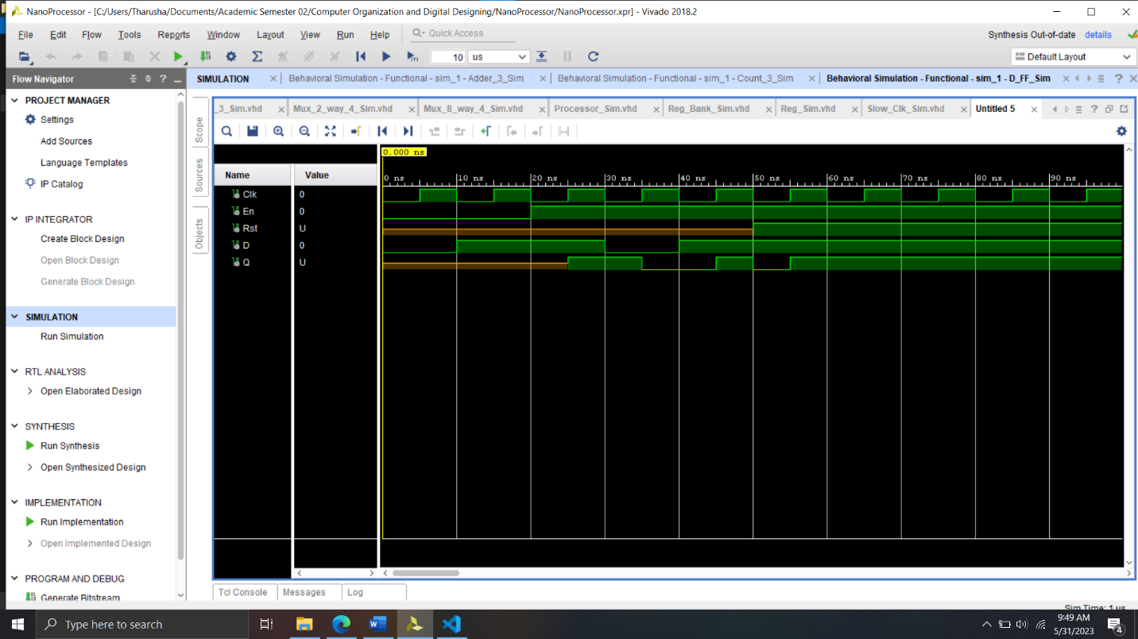

***Sim 3-bit Adder***

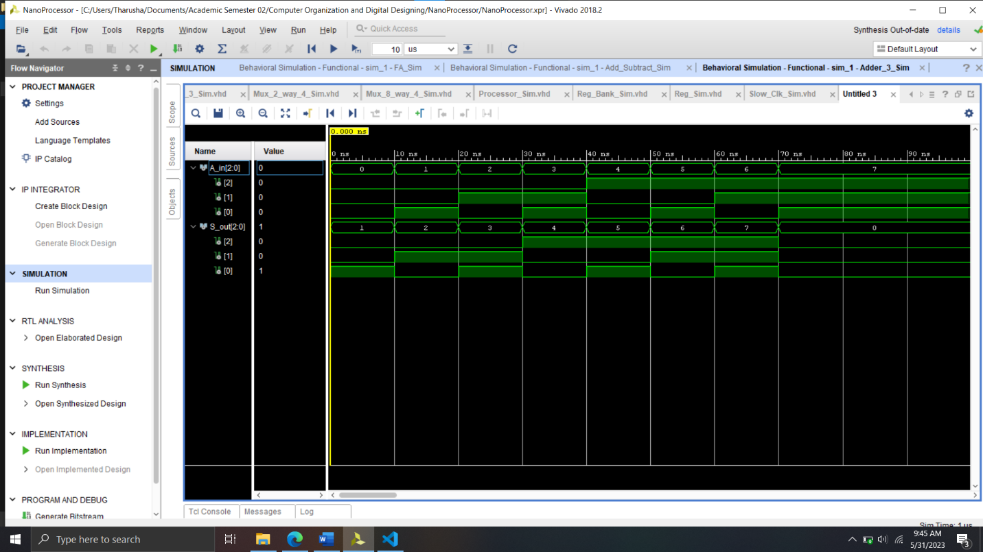

***Sim 3-bit Counter***

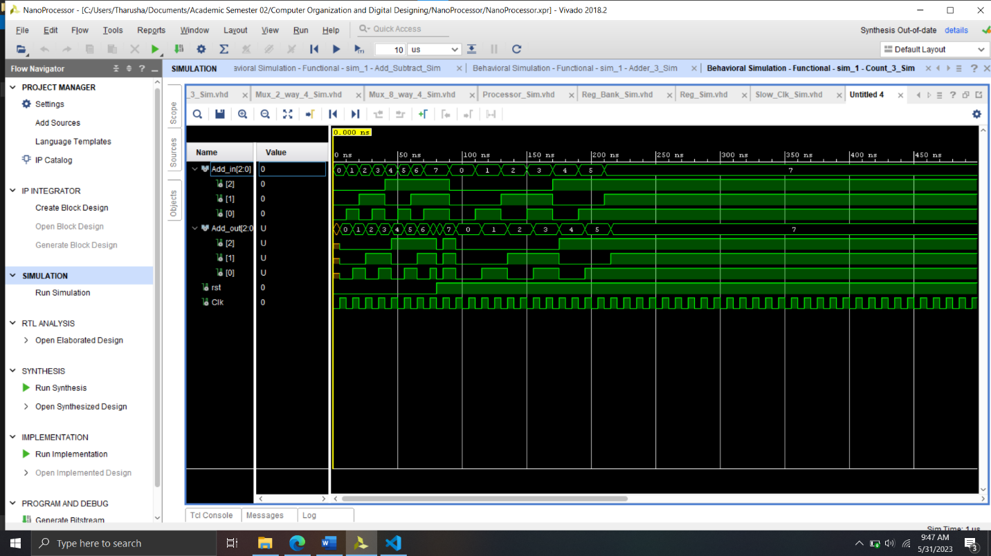

***Sim Adder and Subtractor***

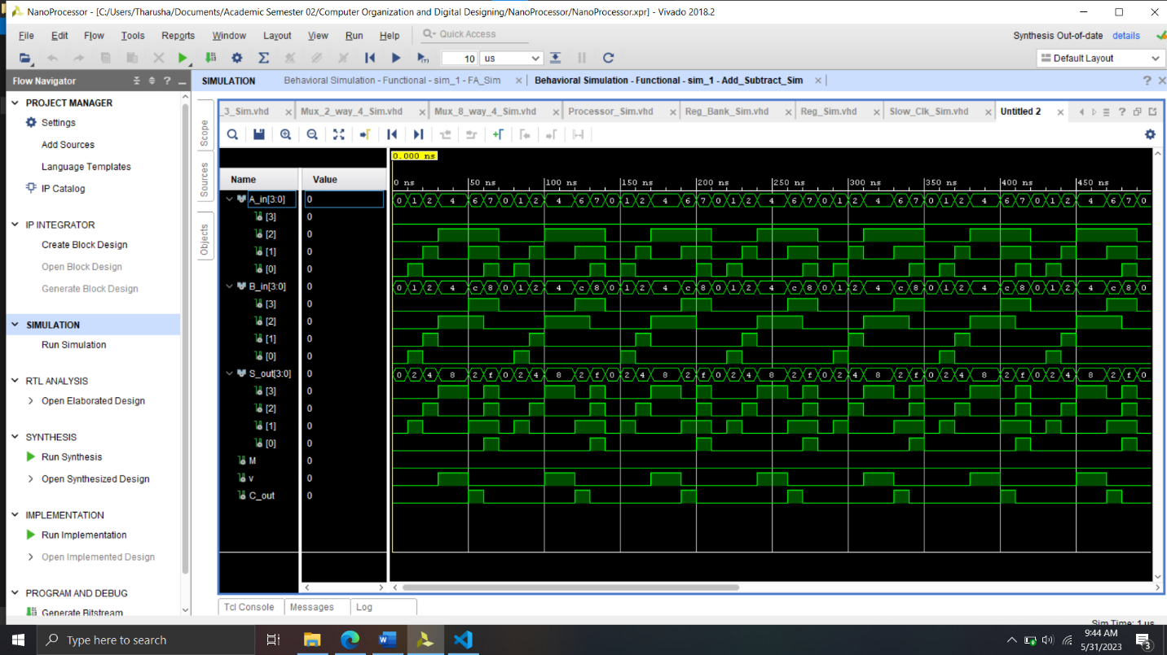

***Sim Decoder 2 to 4***

***Sim Decoder 3 to 8***

***Sim Instruction Decoder***

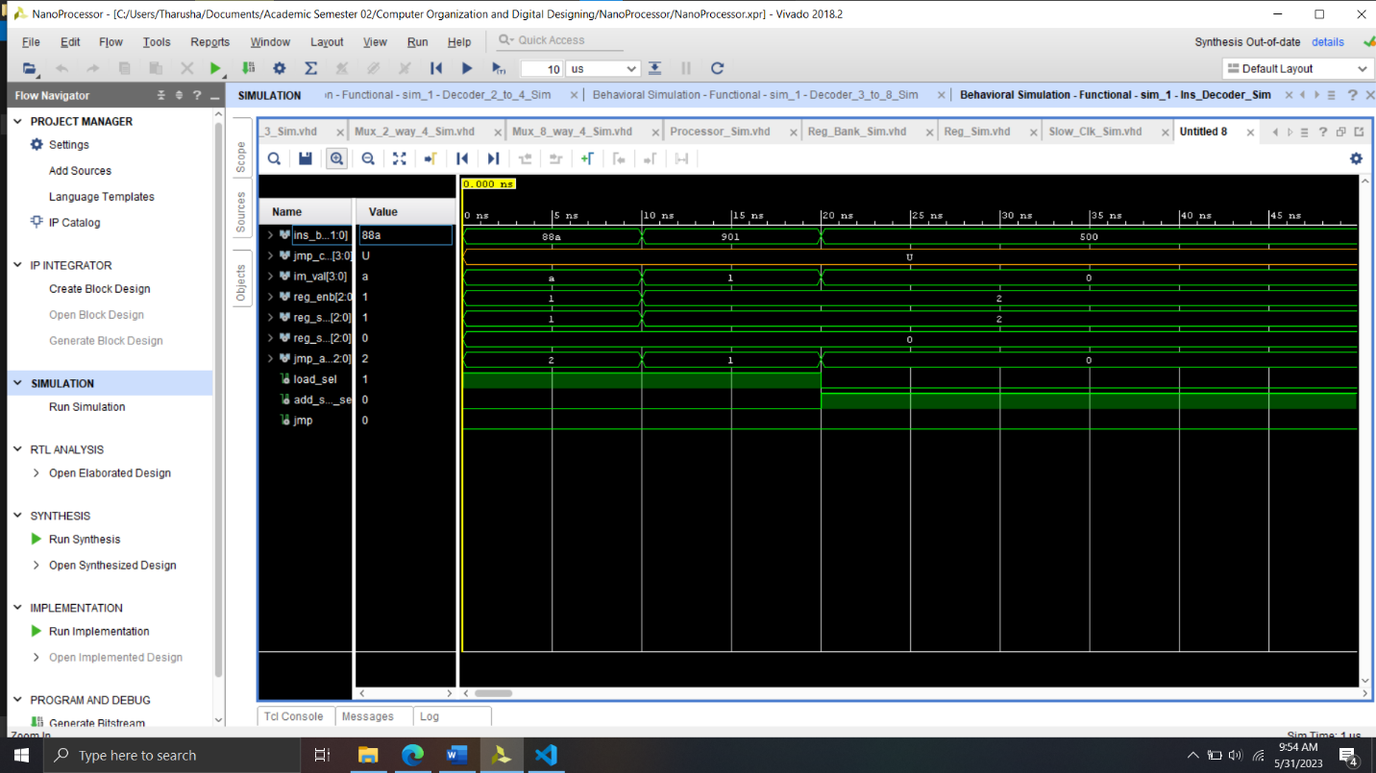

***Sim 7 Segment Lookup Table***

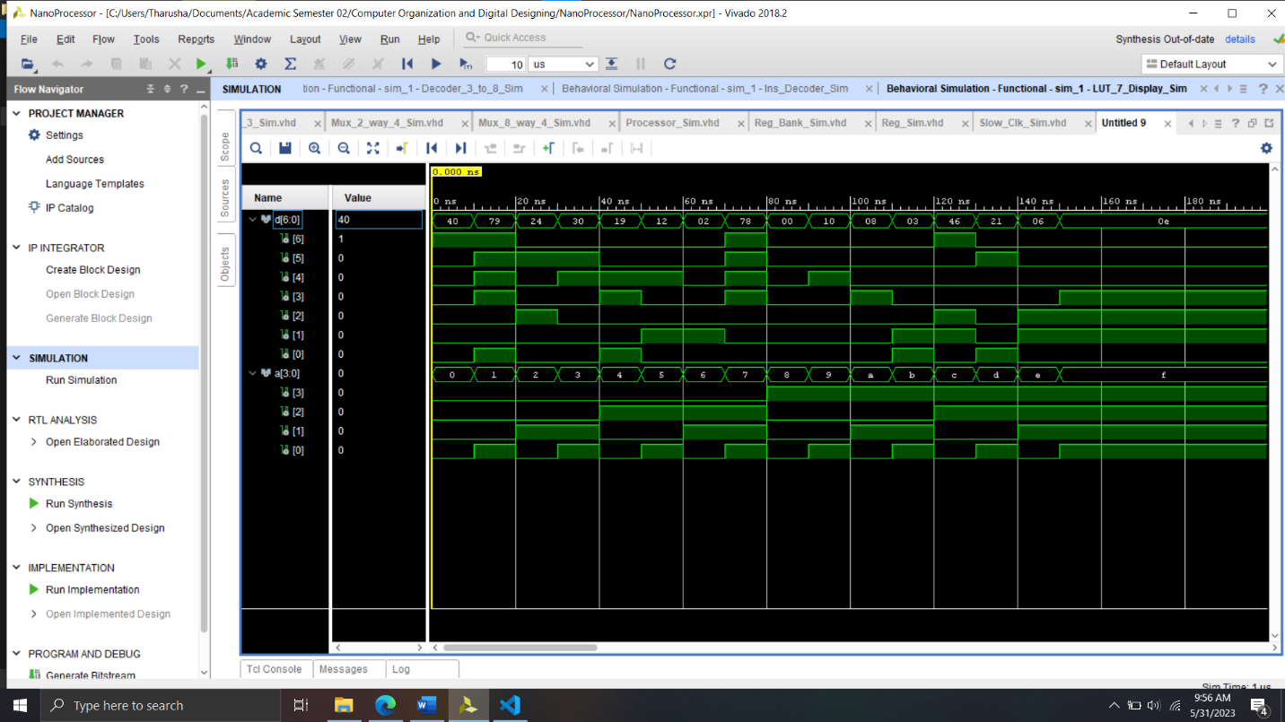

***Sim Mux 2 way 3***

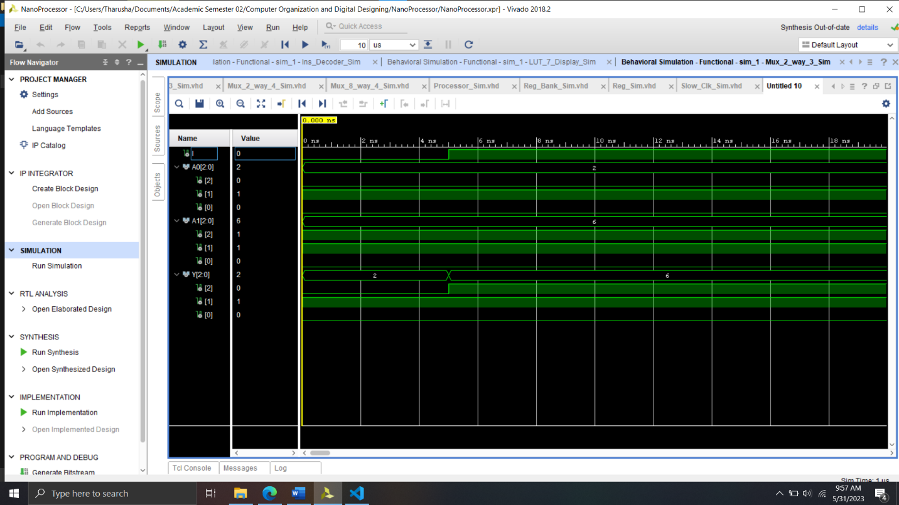

***Sim Mux 2 way 4***

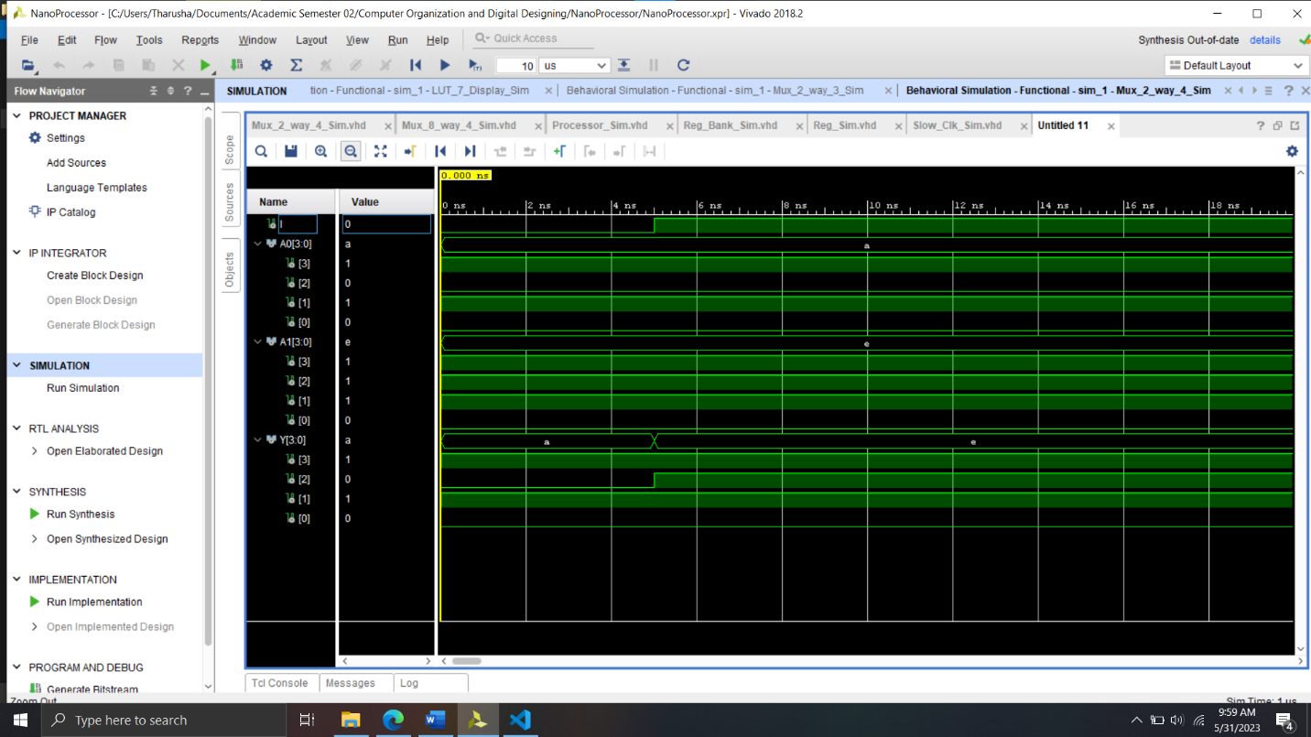

***Sim Mux 8 way 4***

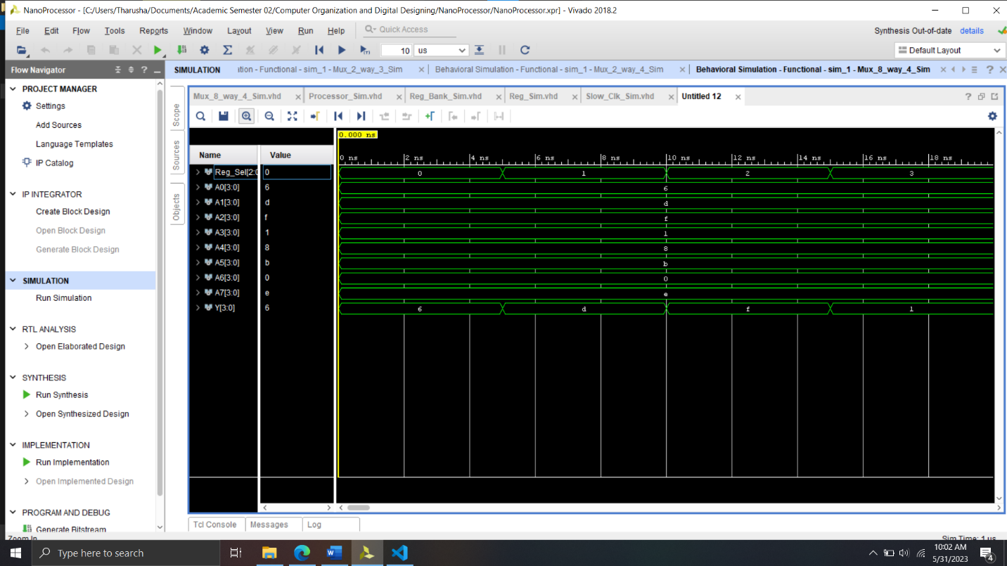

***Sim Register***

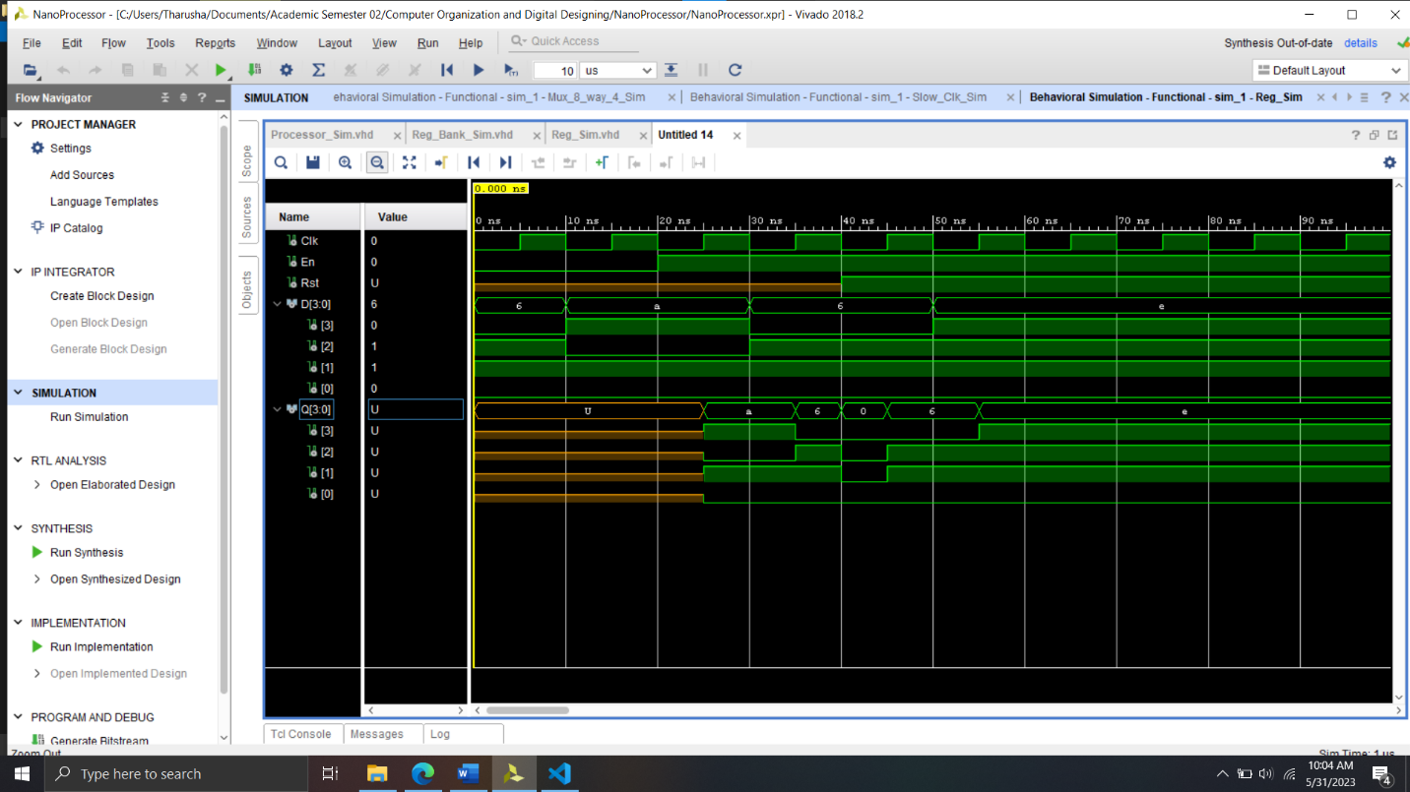

***Sim Register Bank***

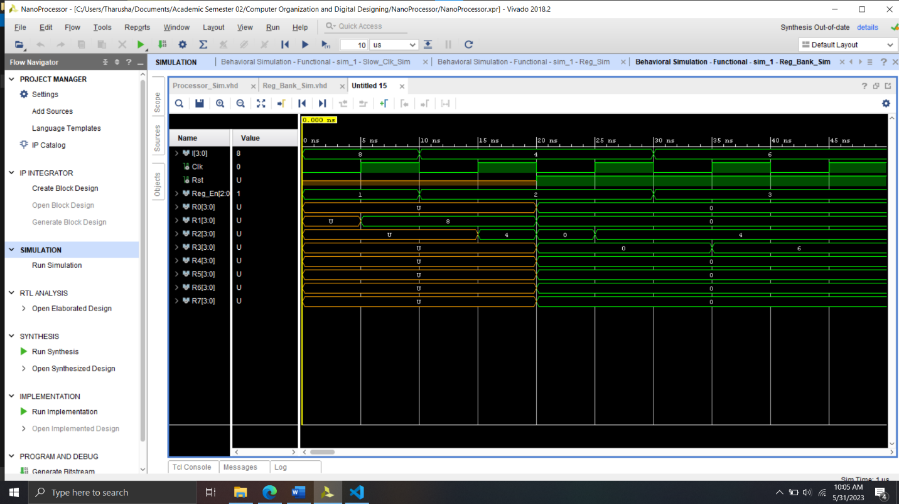

***Sim Slow Clock***

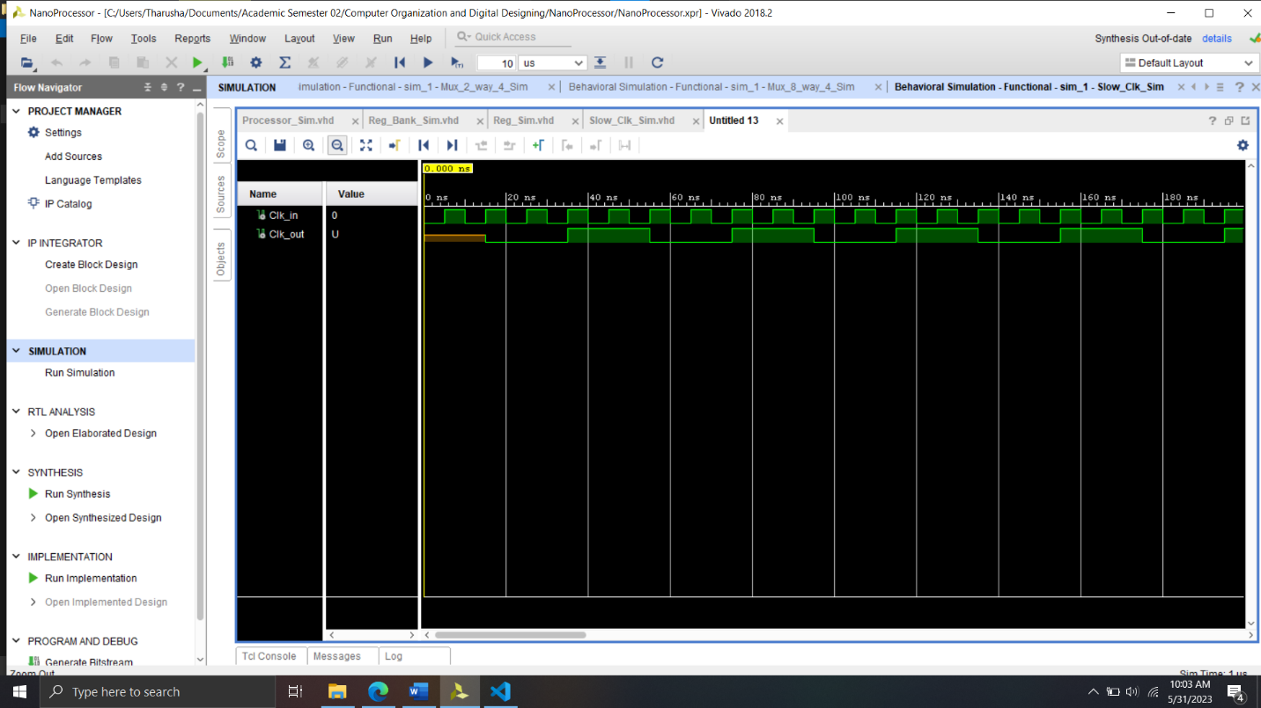

***Sim Processor***

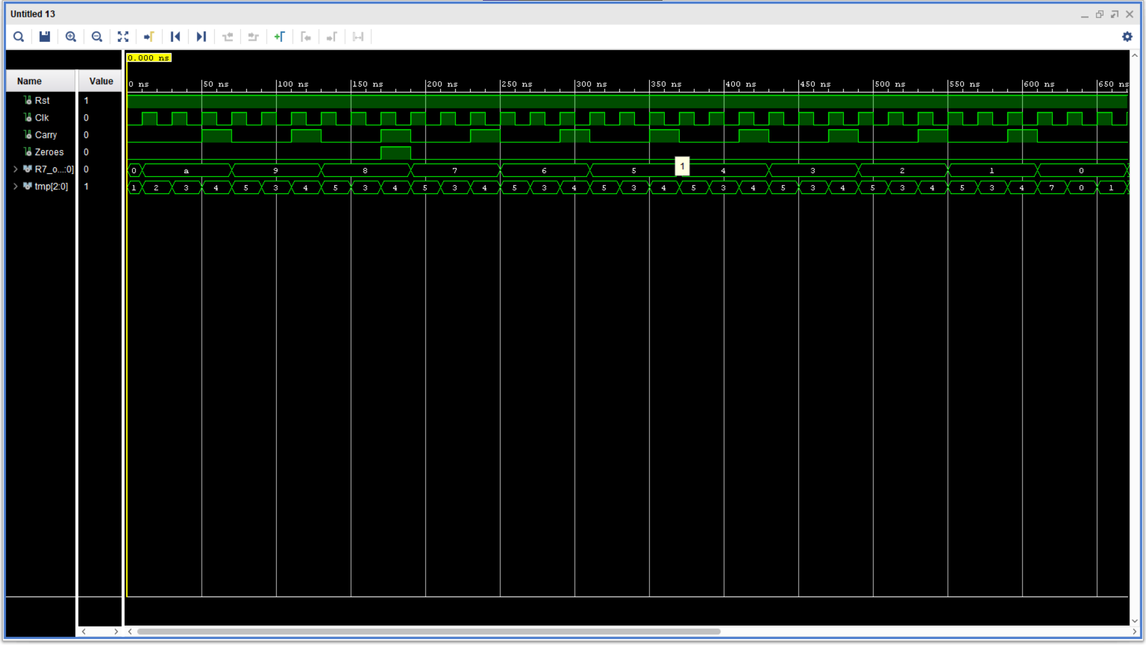

**Conclusion from the Lab**

**Contribution for the project**

*Chandrawansha J.P.S.A*

* *Created Multiplexers.*
* *Created Decoders.*
* *Created Instruction Decoder.*
* *Created Registers and Register Bank.*
* *Designed the ALU.*
* *Created Program ROM.*
* *Created Simulation files for above files.*
* *Designed and constructed the Processor.*
* *Wrote the assembly program and hardcoded associated machine instructions into the ROM.*

*Dinujaya P.H.T*

* *Created Adder.*
* *Created Program Counter.*
* *Created Adder and Subtractor.*
* *Created Lookup Table for Seven Segment Display.*
* *Modified the constrain file.*
* *Created simulation for above files.*
* *Simulated the processor.*
* *Created Lab report.*